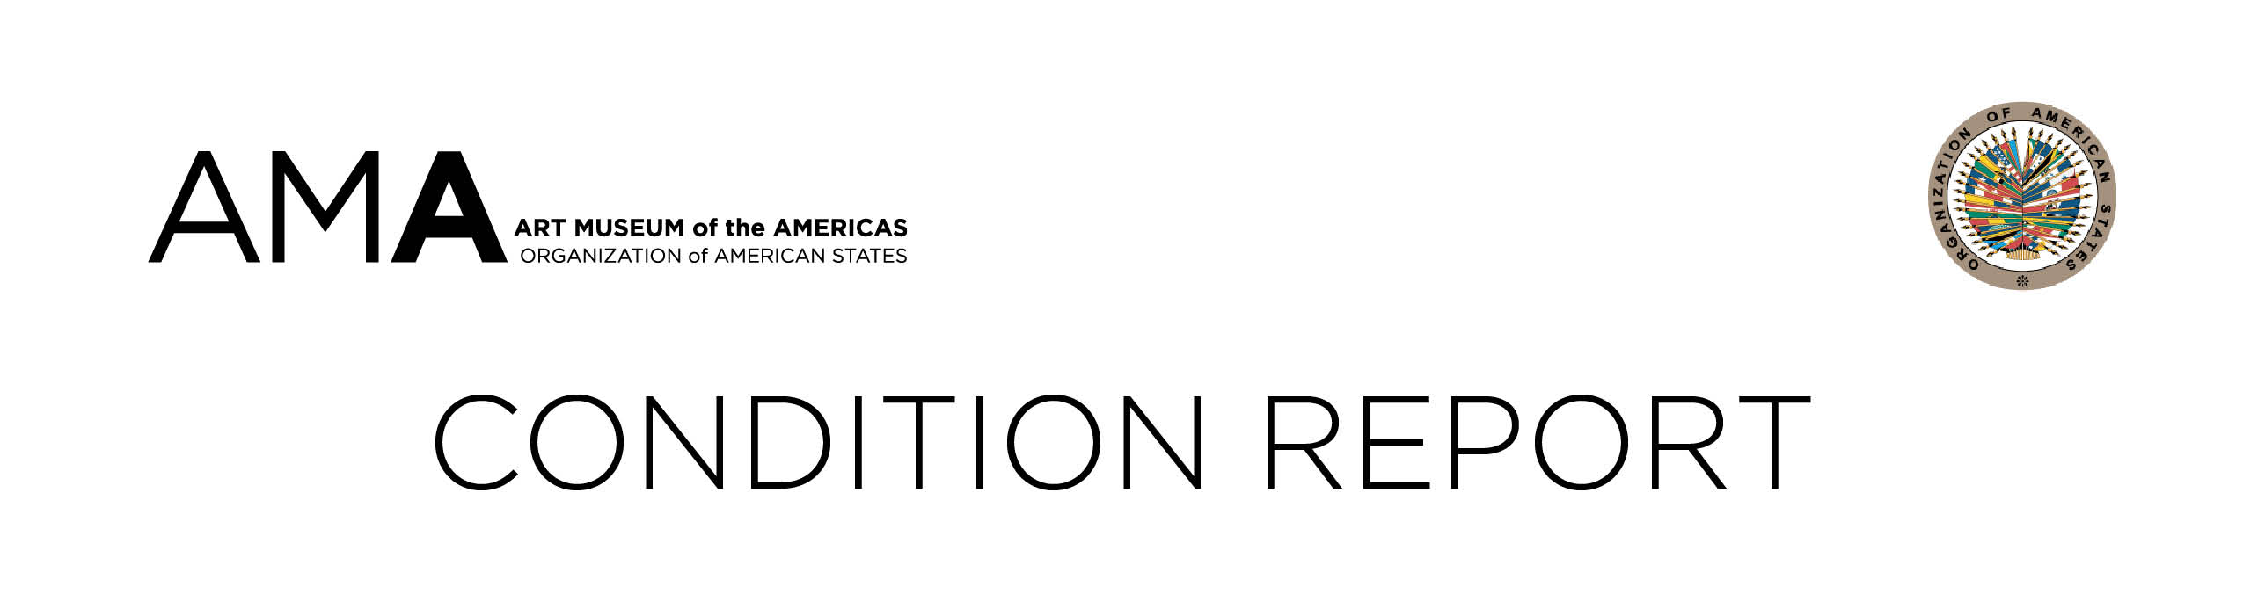

CONDITION

COMMENTS

SIGNATURE DATE

